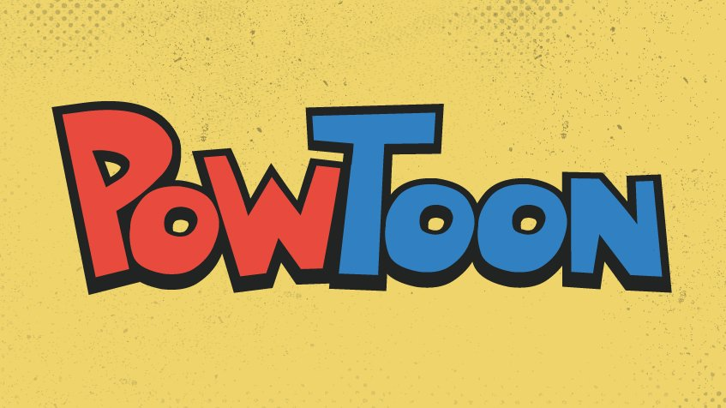

Your box may not be enough to tell us ALL about your dorm room. You will create a PowToon to showcase your dorm room ( the same one as you chose for your final).

Step 1: Go to https://www.powtoon.com/home/?
Step 2: Create an account, or log in.
Step 3: Create a PowToon that showcases your dorm and it’s campus. Your PowToon must have at least 10 pages/slides and include 15-20 facts about your dorm/college. You must include icons and not just have words.
Step 4: When done, publish it so others can view it.
Step 5: Using this website: https://www.qr-code-generator.com/
Create a QR generator for your Powtoon.
Step 6: Email Mrs. Kavanagh your QR code

