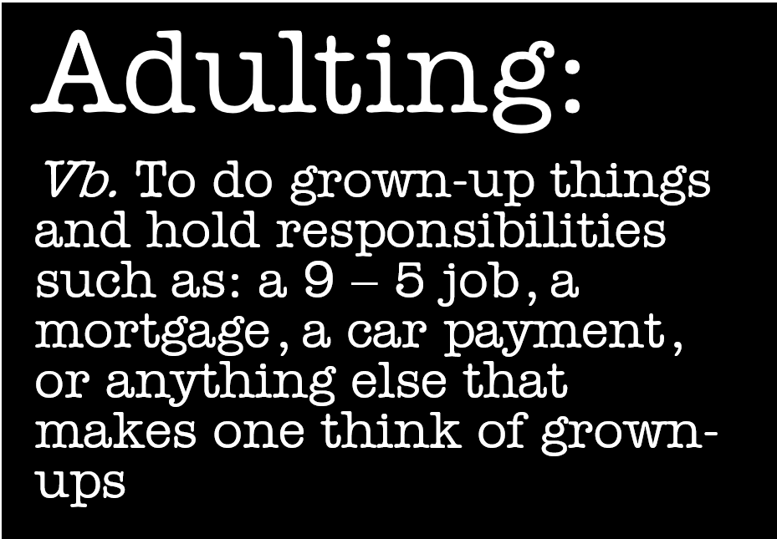
Living:
How to look and shop for apartments
How to iron clothes
Sew on a button
Hem pants/skirt
Balancing health and nutrition in college and early adulthood...how to plan, shop, and cook easy healthy meals, how to prioritize exercise so you stay healthy, how to let go of unhealthy habits.
How to use a thermostat, how to turn off water to a toilet, how to change filters, how to unjam a garage disposal, how call a stranger or business, how to coil a hose, how to clean gutters, how to paint, how to pull weeds / use Roundup, how to change a wiper blade
How to do laundry
How to plan a nutritious menu for the week based on what you have to do that week (maybe you’re really busy, so it’s a crockpot night?), make a grocery list, and then shop for the best deals so that they can have healthy food, but within their budget.
How to load and use a dishwasher.
How to wrap a gift
Put sheets on a bed.
Making coffee
For apartment living time- changing the furnace filter, where the water shutoff and electric box are located. What is their responsibility and what owner/rental company covers.
Grocery shopping Sheet sizes, otc cold medicine, how to ask for help from campus services
cooking. Used next generation personal finance to do some financial literacy. Time management. Scheduling college courses.
ways to be healthy living away from home they also wanted a car dealership representative to come in to take about leasing and purchasing a car.
Quick make and take meals- overnight oats, breakfast burritos
Basic car maintenance, understanding basic finances (personal, taxes), cooking (measurements, simple recipes), how to call and talk to any business you might utilize (utilities, drs), sewing, computer skills (not social media or typing, but real skills like external hard drive, clearing misc data or files, etc)
Reading and understanding a lease. Searching for a property and finding one within budget (including first month/last month).
healthy vs unhealthy relationships, stress management, yoga, suicide/self-harm awareness, self-defense
living with a roommate
Healthy grocery shopping on a budget

Communication:
What your digital footprint says about you
-attaching a file to an email
how to handle conflict and when to call authorities
-arriving 15 minutes early to show respect for the person you're meeting
Mailing a package
Writing thank you notes
Addressing an envelope/ putting a stamp on an envelope
Making a phone call to inquire information
How to write a formal letter or email
Network for jobs
Write a resume
Writing thank you notes
Calling to make a doctor’s appointment
Talk to doctor
Talk to insurance
Making friendships outside of the school environment. The art of having a conversation.
How to cancel services
Having an appropriate email address that is checked regularly
Job interview skills (dressing appropriately)
How to speak over the phone with financial aid...any company for that matter. What the word deposit means in terms of leasing an apartment.
Filling out applications for jobs, apartments, loans, etc
People skills, dealing with customer service reps (both sides of it).
Booking appointments, picking up prescriptions, balancing a checking account
Manners and dining ettiquette. (Napkins on laps, which fork to use, how to cut a piece of meat (we practiced with donuts) etc). I also cover common courtesies and email and texting tips
Body language and non-verbal communication
cover letters/resumes
asking for a raise
Emailing a professor
Writing a formal letter!
Email etiquette, proper internet searching skills, how to build a resume, portfolio writing, proper dressing for an interview

Financial:
Students desperately need information on not just activating a credit card, but credit in general. They need to know that their rent, phone, and medical bills affect their credit score. They need to know that credit can be a good thing, and that they will need to establish a credit score. Their local credit unions will probably offer a "secured credit card", which is a great option for a first card. I saw so many people who were older and working desperately to repair their credit so that they could get a car loan, home loan, etc.
Have them research apts and figure out how many hours they will have to work in order to live there
smart money habits
Save money
Open bank account
-activating a debit/credit card
-balancing a checking account
Your credit score is as important as your reputation
Write a check, doing taxes, how to calculate student loan payment, cost of degree vs potential income, basic cooking lessons
Saving money for retirement the minute they get a job so they will have enough to retire on.
How to open a bank account and deposit money with a deposit slip. Then, not to randomly give your info out to a guy offering “free” pizza on campus.
Budget paycheck for bills, food, and fun
Create a budget
COUPONING- rewards programs
How to buy car or renters insurance
How to buy or lease a car
How to coupon or bargain hunt
How to rent an apartment on a budget
How to choose jobs that will cover all my bills and spending
Understanding healthcare/benefits
-Interest rates on things
Understanding how loans (and loan forgiveness work)
Reading the credit card offer paperwork
Writing a check
How a debit card works.
The impact your credit worthiness has on costs.
Taxes, understanding when they need to start filing, how to fill out a 1040ez. How to complete a W-2 so that the correct amount is withdrawn
Searching for a credit card with good rates. Understanding credit scams.
counting back change

Insurance:
Life insurance
renter’s insurance
Read an explanation of benefits statement
How to get and evaluate the best plans for health insurance, car insurance, disability insurance, etc

Miscellaneous:
Voting applications and how to research candidates for local govt races
Jury Duty and civic responsibilities. Also, consequences of not paying tickets.
strategic thinking
Memorizing their social security number.
How to find a reputable service person (car maintenance, home maintenance, etc).
To check their snail mail and not to let it pile up
City bus system
Change a flat/check oil in a car
Renewing driver’s license, car tags
Getting your car serviced regularly
-being aware of your surroundings
pre-learning and assessment of prior knowledge
how to overcome a stumbling block.

* * * * * * * * * * * * * * * * * * * * * * * * * * * * * * * * * * * * * * * * * * * * * * * * * * * * * * * * * * * * * * * * * * * * * * * *
Interest rates and how they can fluctuate
How to request an estimate for home repairs, how many estimates to get, and how to choose which company to go with. I've rented places to live where we just had to contact a super for repairs and also rented places where we had to get the repairs done & submit our receipts with our rent check for either reimbursement or a discount on the next month's rent. Now as a homeowner, this skill is very important for any kind of repair or work
how to file an insurance claim for auto, home, or renter's insurance.
What preventative / regular medical appointments you should have and when.
HR block has a simulation 4 times a year called “budget challenge”. It lasts about 8-9 weeks. It’s awesome! These kids get real bills, paychecks, etc and have to physically go in to pay bills. Various things happen like a robbery and car accidents in which student work with deductibles abs claims. They get points for being on time and staying ahead on bills. My kids loved it because they compete with each other!
Budgeting, credit, avoiding scams and fraud, grocery shopping and basic cooking, interview tips, dressing professional, taxes (one activity was filling out a 1040ez), changing a Tire.
Writing a check, planning a formal dinner/get-together, table etiquette, writing thank-you cards, house cleaning, doing laundry
Addressing an envelope
Letter writing business & personal
Appropriate way to write an email
Budgeting
Writing a check
Counting back change
Getting car/renters/ etc insurance
Sewing on a button
Making a pot of coffee
Basic cooking skills - scrambled/boiled eggs
Laundry and ironing
Basic sewing/mending.
Lease vs buying a car.
Saving money.
Organizing an event like a work party or wedding.
Making a large purchase: checking reviews and consumer reports.
Cooking skills and recipes, household appliances, household cleaning, personal hygiene
dress for success, body language, remembering passwords (having a central place to document or store them!), emotional intelligence, and sometimes just learning how to let go & move on especially with drama & hangups
Changing mailing address
-Making appointments and keeping them
-sending thank you cards or holiday cards
-couponing
-saving pictures in different areas (apps, print, etc)
-finding positive stress relievers
-making adult friends
doing taxes (1040ez)
sending a thank you note or writing a complaint letter
buying/leasing a car and the upkeep costs
investing/stocks
how to vote/who is your political rep and what do they stand for
booking a plane ticket
The importance of greeting others appropriately before asking something of them
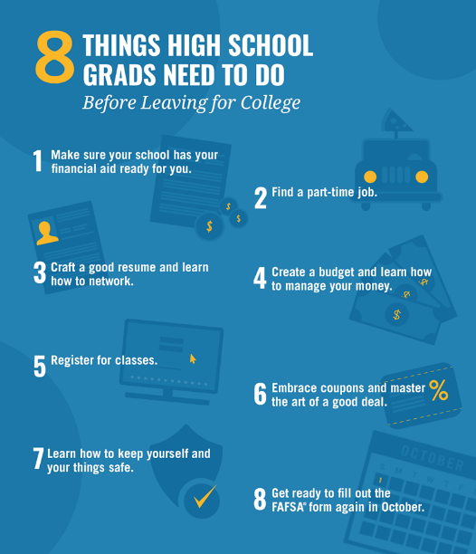
https://www.ngpf.org/
https://www.therideronline.com/?s=adult&submit=Search
Controlling your debt/credit.
Retirement savings
Generic vs name brand
Setting auto pay on bills, using budgeting tools offered by bank, not signing up for crazy credit card deals when you go away to college, how to use an iron, tie a tie, be punctual or early
Professional dress, interviewing, resumes
Things that your landlord/apartment management is responsible for fixing. And how to approach them to get it done.
how to fold sheets and how to put hem on the bed
how not to be scammed online, how to get car insurance
How to turn away door-to-door salespeople & peddlers.
Filling out a job application. Shining shoes, ironing clothes.
How to dress for a FUNERAL
Health stuff too. Knowing their coverage and what to do when they get sick or injured
Paying back student loans
Professional email etiquette (not only for work but college professors), true professional dress/mock interviews, health insurance/life insurance options, understanding credit & impact of paying on time, budget management
Professional email correspondence, cover letters
How to make restaurant, hotel, flight reservations
How to know when they can fight back (if they’re being taken advantage of) with a business or organization.
the value of home warranties and when you can diy
Professional etiquette when eating with boss/peers as well as things like hostess gifts.
Understanding that rent may not include everything. What monthly Bills truly look like.
How to follow up with a company when you do an interview, real cost of living and how to budget! What your credit score is, why it’s important, how it works.
Build your Resume/ looking into internships in college
How hourly pay turns into the paycheck...taxes, deductions = bring home pay = budget
Correct Diction
Car routine maintenance checklist (also for a house - like air filters & winter prep)
Accepting criticism/correction without a meltdown
Coping skills without drugs, medicine
Importance of RSVP & TU notes
A proper CV
Budgeting - don’t plan on SS in retirement
Traveling – checklist
Setting up your 401k
What you need to be able to rent a house/apt
Getting stains out of clothes
Property taxes

