Name ______________________________________ Date ________________________________ Period ___

Healthy Eating in College

As a freshman in college, you will take even more ownership of the food choices you make. Unfortunately, most college students make poor choices when it comes to food. Often the price and taste are more important than the nutritional value. For this reason, college freshmen tend to gain weight in their first semester. You may have heard of the “Freshman 15” which refers to the amount of weigh freshmen are said to gain in their first semester of college. Actually, it is usually somewhere between 3-10 pounds. Some of the causes of weight gain include: lack of exercise, eating late at night, keeping unhealthy snacks on hand (in the dorm room), and eating unhealthy cafeteria food. For this project, you will research and prepare a healthy dish that meets the guidelines below. You will then share copies of the recipe and the dish with your classmates at a pot-luck on Friday, April 28th The purpose of this project is to provide you with several healthy, cheap, and easy-to-make recipes that you can take with you and prepare while you are in college.

Portfolio Requirement:

- Submit this recipe document, and make sure to include a picture. Mrs. Kavanagh will have to give you access to this document.

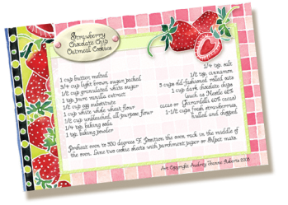
Recipe Guidelines:

- Must cost less than $2.00 per serving to prepare
- Must be a recipe for breakfast, lunch, dinner, or a healthy snack
(no desserts)
- Must be easy to make
- Must be tasty!

Project Guidelines:

- Must present to the class how you made your recipe and why it is a healthy choice
- Must bring in your prepared recipe for the class to sample, roughly 10 samples.
Recipe Ideas:
- Google “Healthy and Cheap Recipes for College Students”
- Google “Low Calorie Meals”
- Ask mom for a healthy recipe that you enjoy at home
- Visit: https://www.yummly.com/
http://www.mnsu.edu/shs/healtheducation/bmc or http://www.onlinecollege.org/2009/10/13/100-delicious-dirt-cheap-recipes-for-the-starving-student/

